

Contenidos.

Simplificación booleana. 3

Tablas de verdad. 4

Implementaciones. 5

# Simplificación booleana.

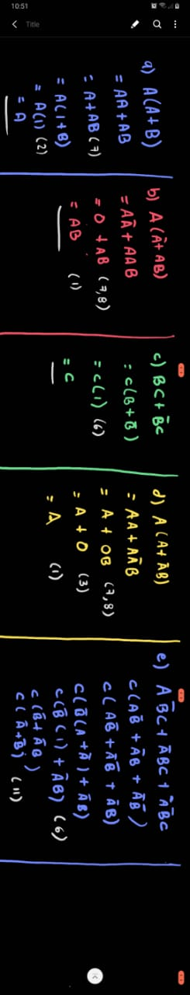



# Tablas de verdad.

a)

|  |  |
| --- | --- |
| A | Output |
| 0 | 0 |
| 1 | 1 |

b)

|  |  |  |
| --- | --- | --- |
| A | B | Output |
| 0 | 0 | 0 |
| 0 | 1 | 0 |
| 1 | 0 | 0 |
| 1 | 1 | 1 |

c)

|  |  |
| --- | --- |
| C | Output |
| 0 | 0 |
| 1 | 1 |

d)

|  |  |
| --- | --- |
| A | Output |
| 0 | 0 |
| 1 | 1 |

e)

|  |  |  |  |  |  |
| --- | --- | --- | --- | --- | --- |
| A | ~A | B | ~B | C | Output |
| 0 | 1 | 0 | 1 | 0 | 0 |
| 0 | 1 | 0 | 1 | 1 | 1 |
| 0 | 1 | 1 | 0 | 0 | 0 |
| 0 | 1 | 1 | 0 | 1 | 1 |
| 1 | 0 | 0 | 1 | 0 | 0 |
| 1 | 0 | 0 | 1 | 1 | 1 |
| 1 | 0 | 1 | 0 | 0 | 0 |
| 1 | 0 | 1 | 0 | 1 | 0 |

# Implementaciones.

a)

CircuitMaker

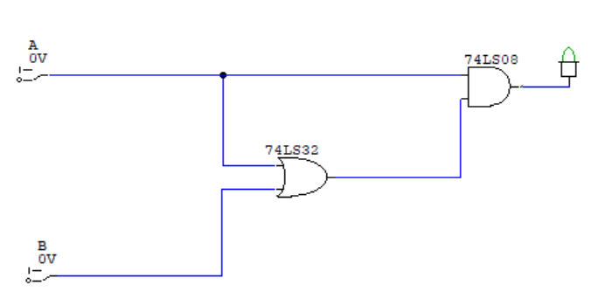

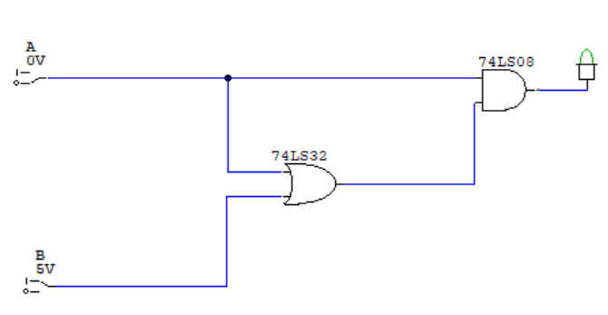

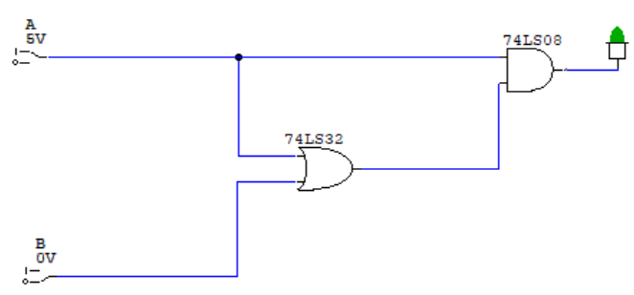

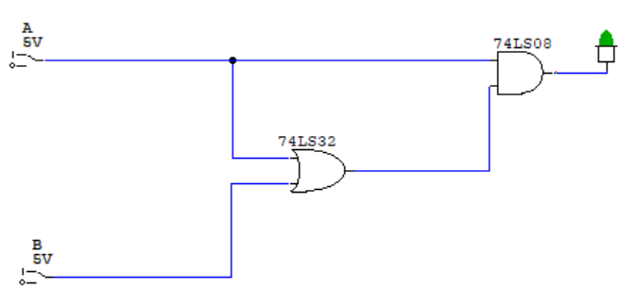

a)

TinkerCard (Solo output = 1)

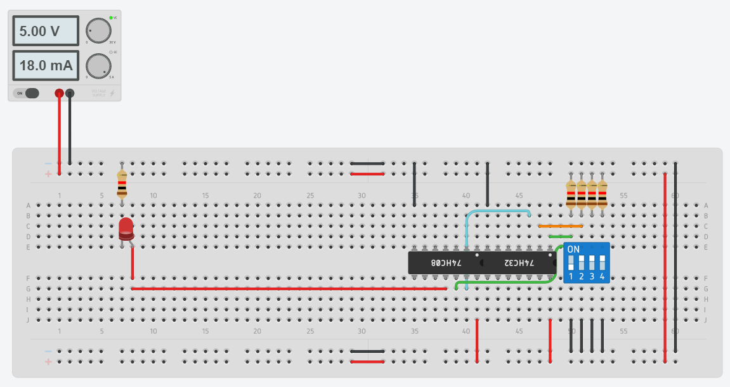

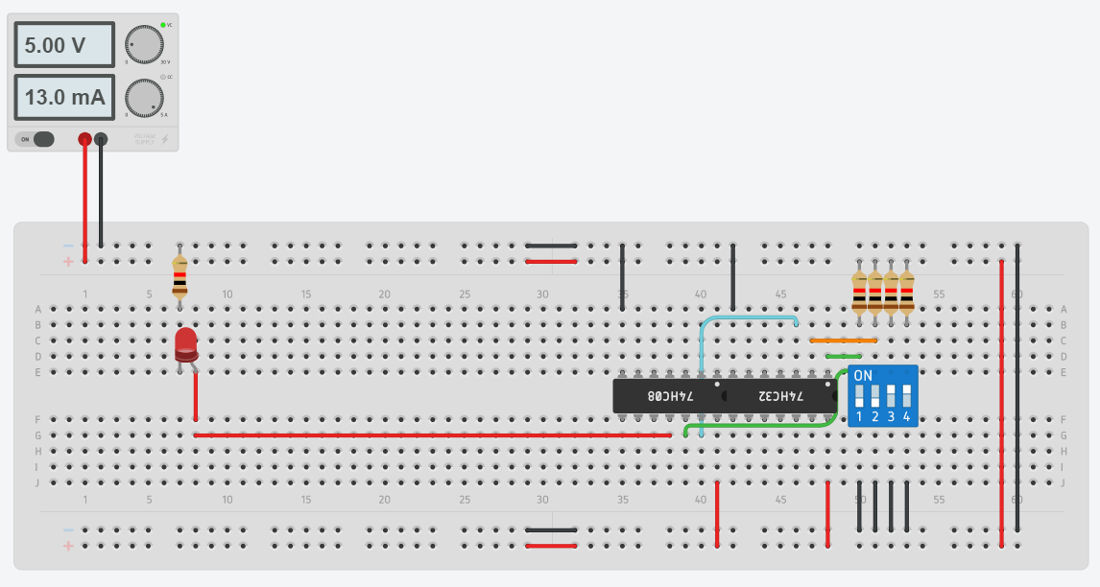

b)

CircuitMaker

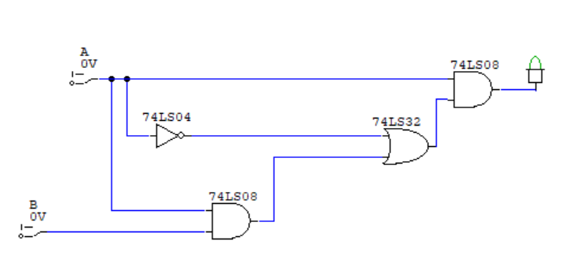

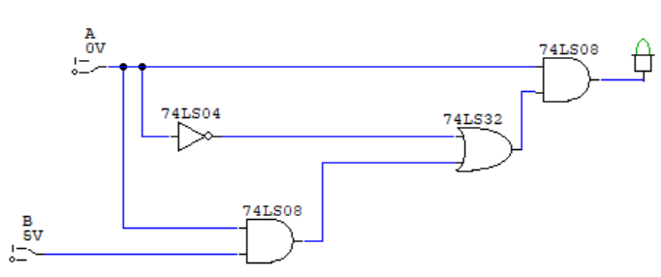

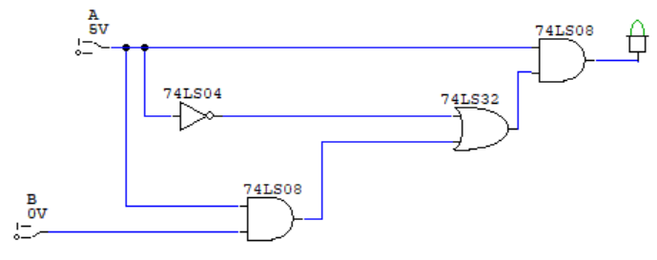

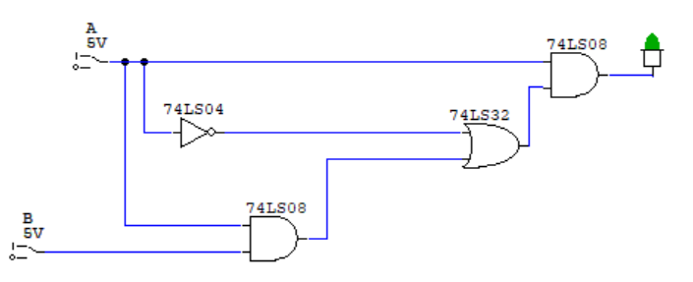

b)

TinkerCad (Solo output = 1)

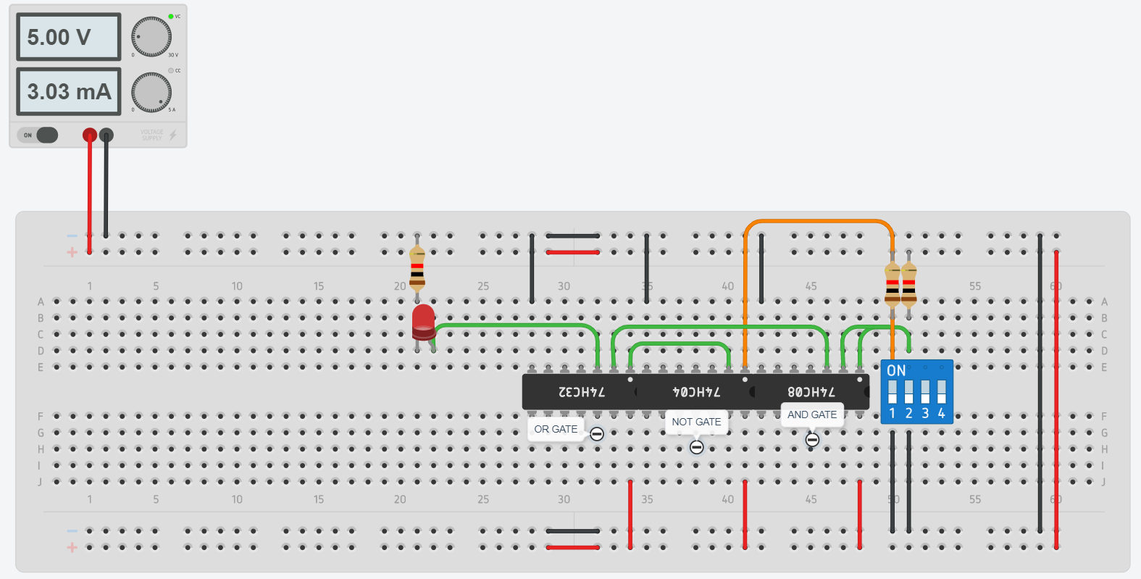

c)

CircuitMaker

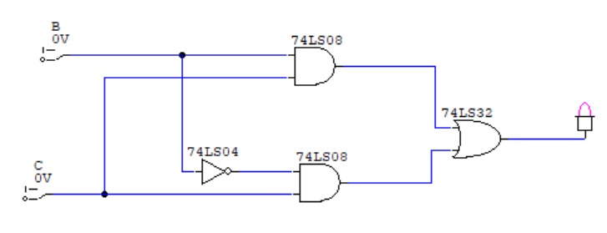

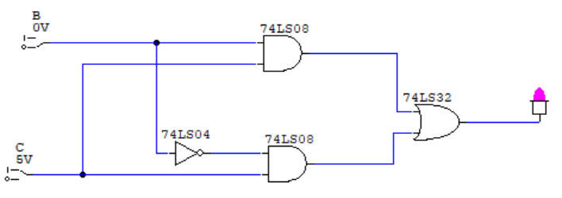

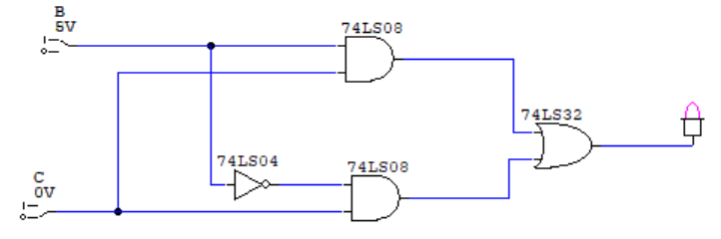

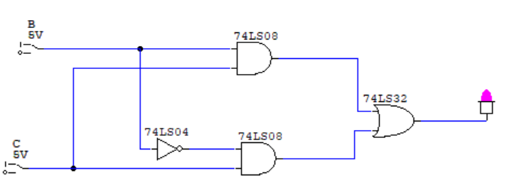

c)

TinkerCad (Solo output = 1)

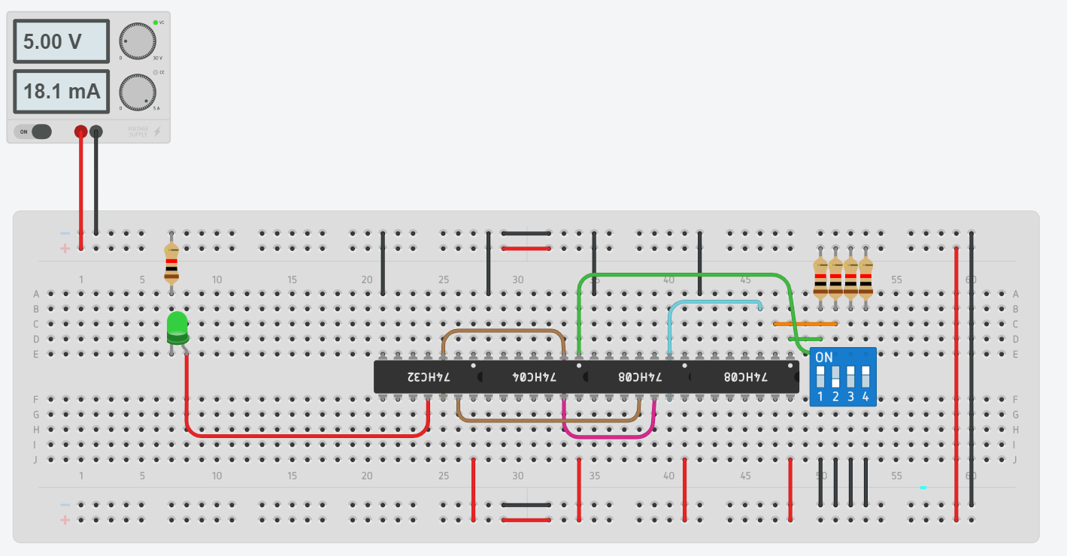

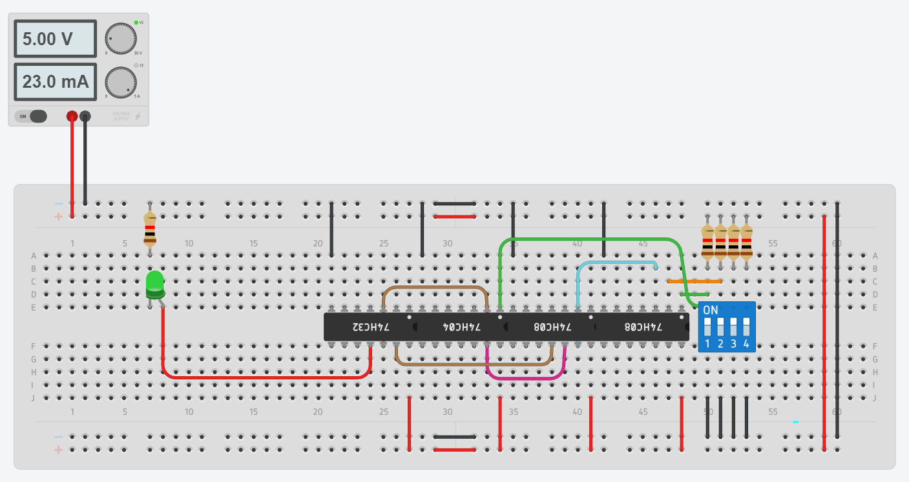

d)

CircuitMaker

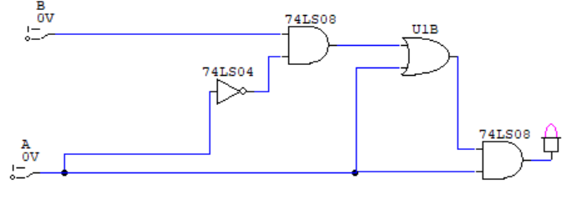

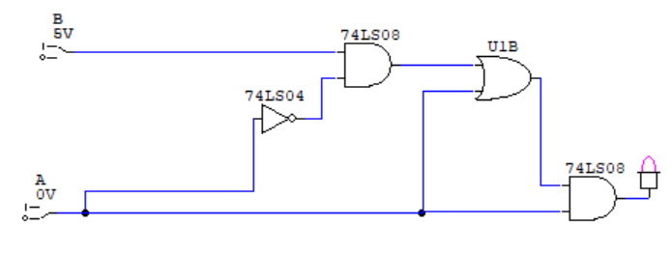

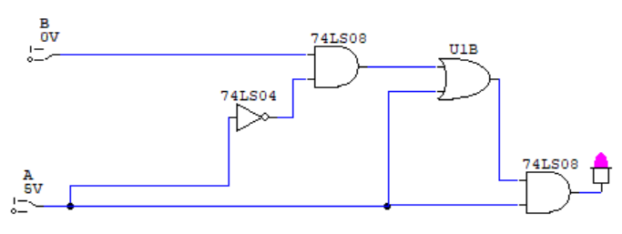

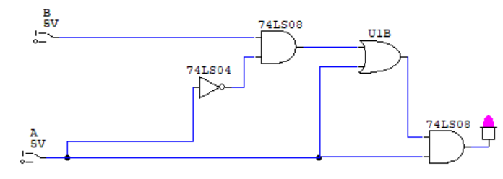

d)

TinkerCad (Solo output = 1)

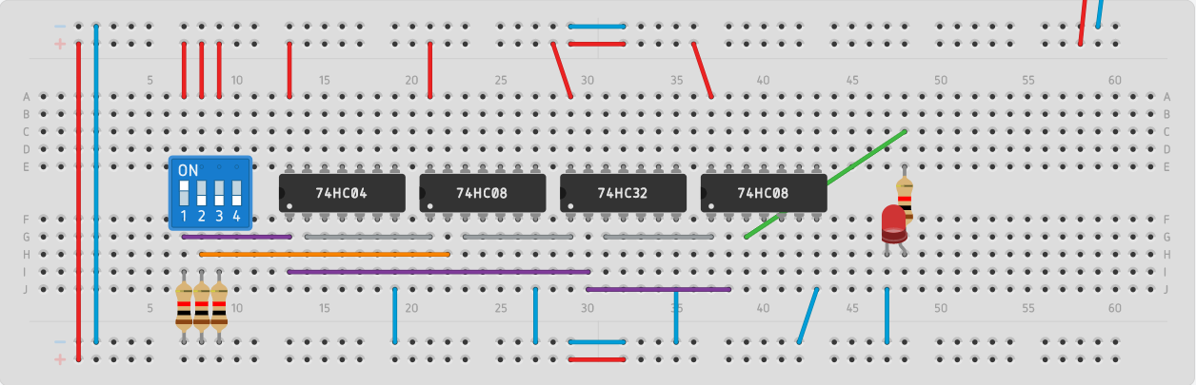

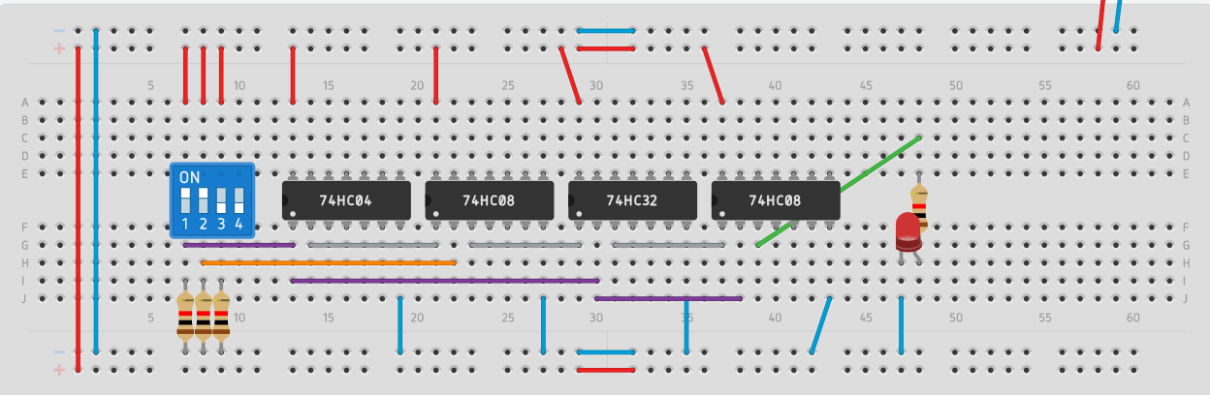

e)

CircuitMaker

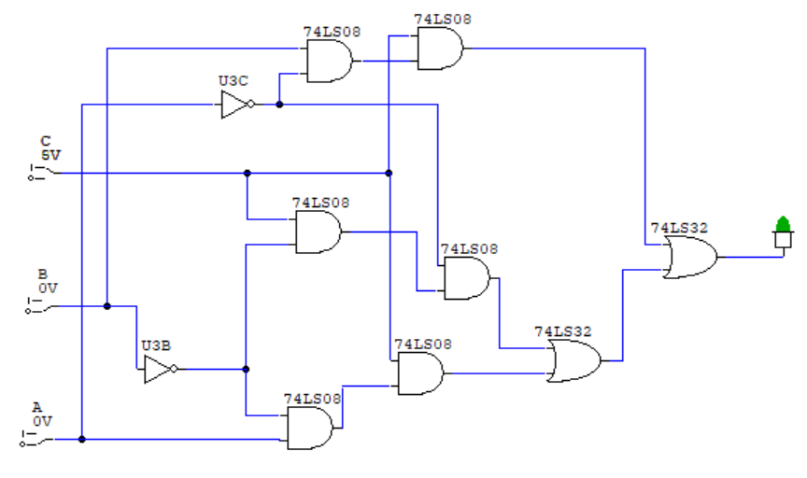

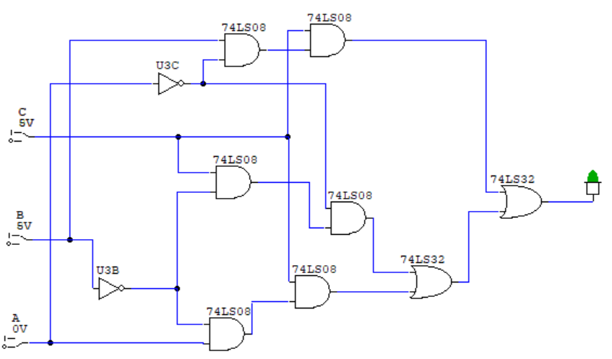

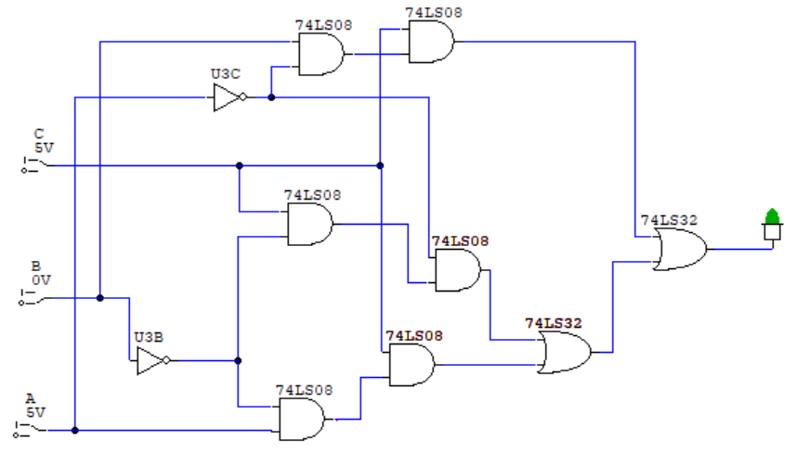

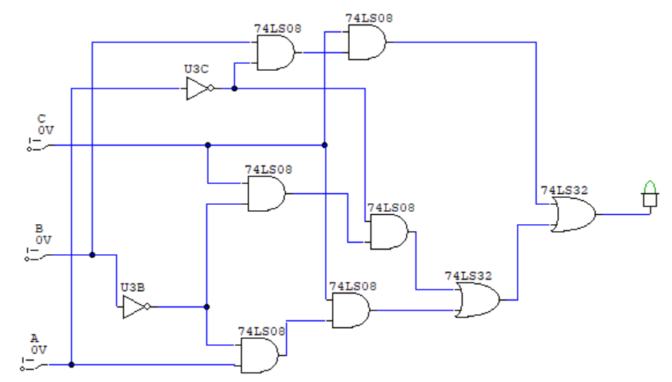

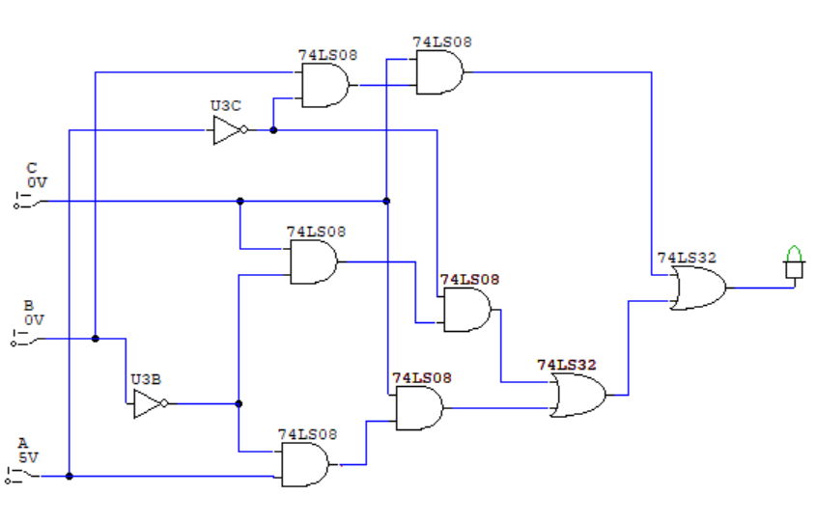

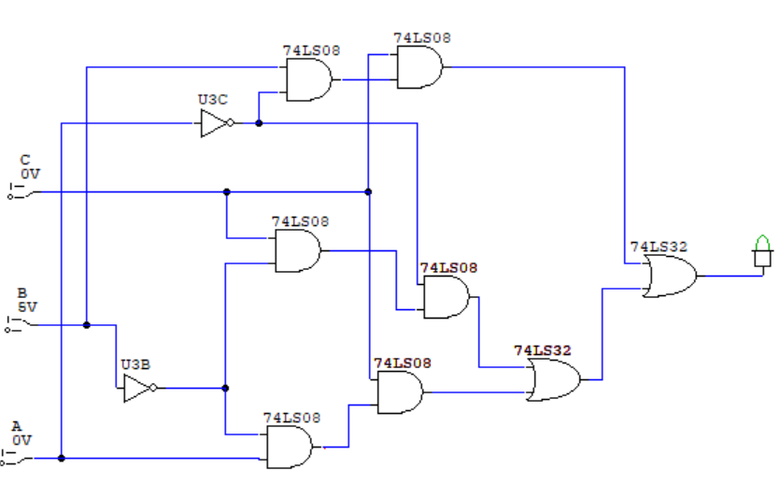

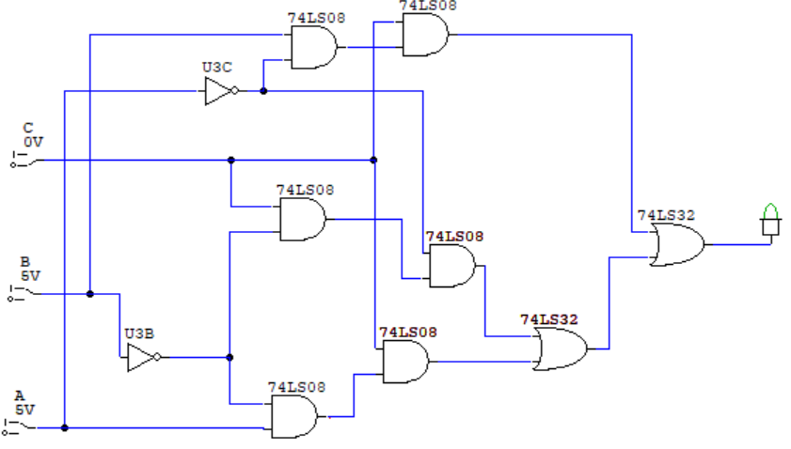

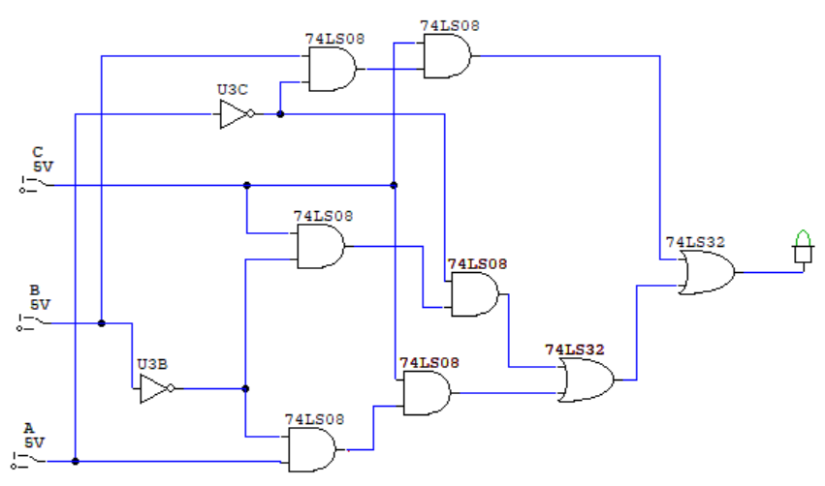

e)

TinkerCad (Solo output = 1)

